**CIPMM**

**Procurement & Materiel Management Mentorship Program 2024**

**Mentor’s Tool Box**



**Welcome Mentors!**

I have compiled some tips, tricks and resources that I find useful for planning my Mentoring Sessions and thought you may find them helpful in your planning.

Sections

**A:** Sample Agendas

**B:** Getting Ready

**C:** Keeping it Fresh!

**D:** Tried and True Topics

**E:** Procurement Pickles

**F:** List of Guest Speakers

**G:** If You Get Stuck

**Section A – Sample Agendas**

These are sample Agendas you can use for your planning. They are normally just used by the Mentor to keep the Mentorship Session focused and organized. They are not meant to be shared with Mentees. Part of the Mentorship experience is for the sessions not to turn into structured meetings but more like facilitated discussions.

**Sample 1 (For First Meeting)**

**Agenda**

1. Welcome & Introductions (Mentor & Mentee’s each do a Quick Intro)
2. Mentor provides an overview of their career and why you are volunteering as a Mentor.
3. Mentor asks each Mentee to talk about their career and what they are looking to get out of the program (Career progression, networking, technical advice etc..)
4. Mentor asks Mentee’s if they have specific topics they would like to cover over the program. Mentor provides some suggestions they would like to discuss (your own or from our list). Mention they can always email you suggestions prior to each session.
5. Decide when you will meet? (From 1:30pm to 3:30pm every second Wednesday of the month for example)
6. If time permits, spend some time discussing what they think are the biggest challenges and opportunities facing public procurement or materiel management.
7. Closing remarks and ask how they will invest in themselves (stretch) by next month ☺ and reconfirm that you will send the invite series via Outlook Calendar and look forward to seeing them next month!

**Section A – Sample Agendas (cont’d)**

**Agenda – Sample 2**

1. Welcome & Check In with Mentees on how their month was and how did they do with their self-investment (stretch).
2. Discuss a recent news article concerning procurement or MM. What is important about this? How does it affect our work? Any lessons learned?
3. Facilitate discussion on monthly main topic (yours or theirs)
4. Share a relatable story from your own career that aligns with the previous topic. What happened? What did you do? How did it turn out? Ask Mentees if they have any to share.
5. Procurement/MM Pickle of the Month. Choose a scenario that describes an ethical, technical, judgement based, people management, supplier/client relations situation etc… and ask what they would do and facilitate the discussion. Let them know what you would do or have done and why.
6. Open the floor- Anything anyone wants to discuss? Career advancement? Dilemmas?
7. Closing remarks and ask how they will invest in themselves (stretch) by next month.

**Agenda – Sample 3**

**(for shorter guest speakers)**

1. Welcome & Check In with Mentees on how their month was and how did they do with their self-investment (stretch).
2. Introduce Guest Speaker (Speaker presents for 30 min)
3. Facilitate Q&A between the Mentees and the Guest Speaker
4. Shortened discussion on your monthly main topic (yours or theirs)
5. Procurement/MM Pickle of the Month. Choose a scenario that describes an ethical, technical, judgement based, people management, supplier/client relations situation etc… and ask what they would do and facilitate the discussion. Let them know what you would do or have done and why.
6. Closing remarks and ask how they will invest in themselves (stretch) by next month.

**Agenda – Sample 4**

**(for longer guest speakers)**

1. Welcome & Check In with Mentees on how their month was and how did they do with their self-investment (stretch).
2. Introduce Guest Speaker (Speaker presents for 45 min)
3. Facilitate Q&A between the Mentees and the Guest Speaker
4. Share a relatable story from your own career that aligns with the guest speaker. What happened? What did you do? How did it turn out? Ask Mentees if they have any to share.
5. Procurement/MM Pickle of the Month. Choose a scenario that describes an ethical, technical, judgement based, people management, supplier/client relations situation etc… and ask what they would do and facilitate the discussion. Let them know what you would do or have done and why.
6. Closing remarks and ask how they will invest in themselves (stretch) by next month.

**Section B: Getting Ready**

* Select what platform you are using - Teams, ZOOM etc… and TEST IT!!
* Practice sharing your screen ☺
* Think about which topics interest you and prepare – our resources or your own
* Check Media for Procurement/MM related stories of interest
* Have a few of your career defining moments ready to share, the good, the bad and everything in between
* Have questioning techniques ready to draw out the more reserved Mentees
* Block the time in your calendar for all your monthly meetings until Oct and make them sacred
* The day before your mentorship session, consider sending a reminder email to the mentees and ask for any last minute topic suggestions they may have
* Don’t take yourself so seriously! The Mentees are grateful to have you as their Mentor and don’t expect you to be perfect. Some of my best sessions have been totally improvised!
* Get ready to have fun, learn and enjoy sharing your journey with the next great procurement and material management professionals.

**Section C: Keeping it Fresh!**

* Try to mix things up and go with the flow to where the group is going. Have a plan but be ready to set it aside
* Bring in a guest speaker, one on our list or colleagues, friends you know
* Keep up with the News! Mentioning current events in procurement/MM fuels discussion
* Ask a Mentee to prepare and lead a topic
* Pick a topic du jour – A new tool, policy etc..
* Step outside of your comfort zone
* Use the resources in your CIPMM Mentor Page
* Checkout the Procurement Community on GCPedia <https://www.gcpedia.gc.ca/wiki/Procurement_community>

**Section D: Tried and True Topics**

* **How to prepare for a competitive process**
* **Success is built on Failure**
* **Future of Public Procurement or Materiel Management**
* **For the Love of Procurement : From IO to EX**
* **Procurement & Materiel Management Code of Conduct**
* **Ethical Dilemmas**
* **Trade Agreements**
* **Bid Evaluation**
* **Mandatory Methods of Supply**
* **Effective Debriefs**
* **PG Competencies and Certification**
* **How to effectively use ProServices**
* **Why does good materiel management matter**
* **The challenge of nailing down that elusive “requirement”**

**Section E: Procurement Pickles**

**Ask Mentees what they would have done under these circumstances. Use difficult or interesting situations you have come across in your career such as:**

* **Difficult Clients**
* **SOW Nightmares**
* **No Bids** ☹
* **Prioritizing files**
* **When things go horribly wrong!**
* **New methods of supply**
* **When you know your boss is wrong – Yikes! How to navigate troubled waters**

**Here are some cases that the Procurement Ombudsman has investigated. They can be used for discussion on what would they have done differently.** [**http://opo-boa.gc.ca/sommaireenq-investsum-eng.html**](http://opo-boa.gc.ca/sommaireenq-investsum-eng.html)

**Section F: List of Guest Speakers**

*Document is also available on Mentor Page

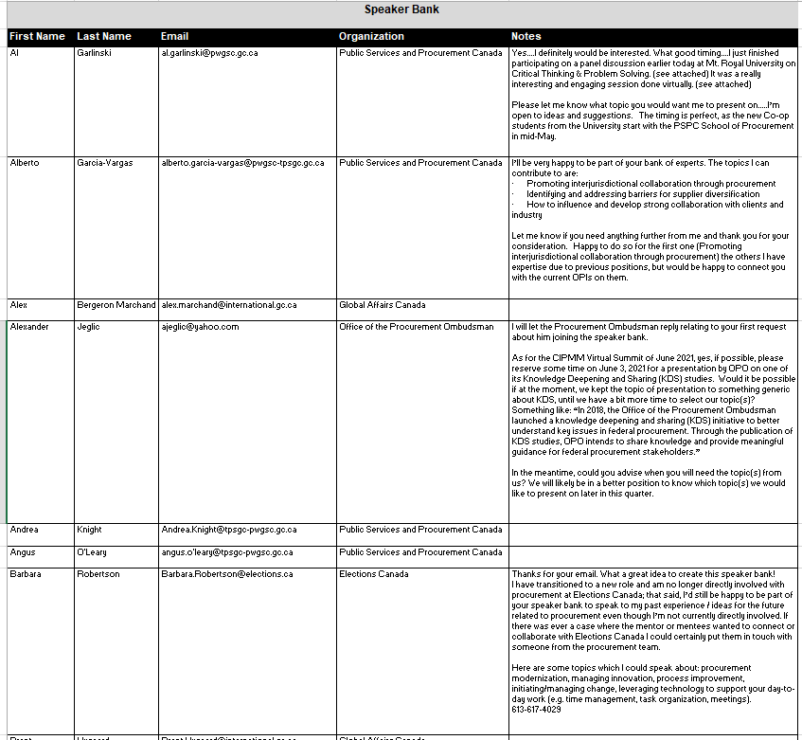

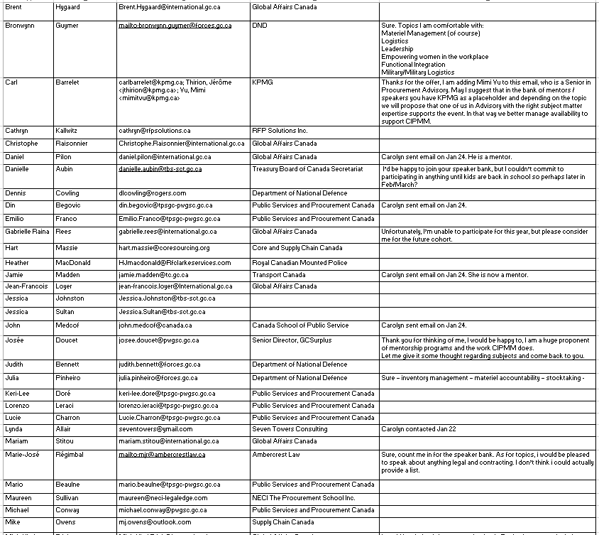

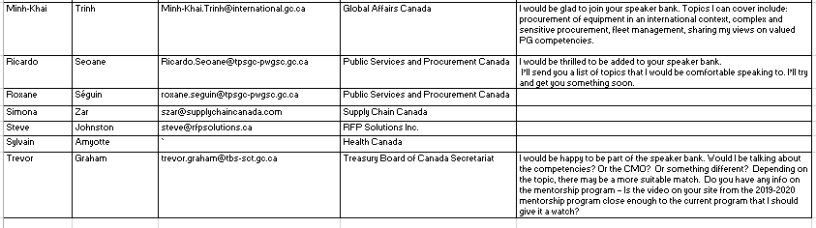

**Section G: If you get stuck**

**Call Me!!!**

**I am always available to help out or get a sub for you if you have a conflict or a last minute urgency and can’t make your session. My self and the other returning Mentors are happy to help out if you need ideas/topics or have any questions.**

***Caroline Landry***

Chair, CIPMM Procurement Mentorship Committee

[Caroline.Landry@tpsgc-pwgsc.gc.ca](mailto:Caroline.Landry@tpsgc-pwgsc.gc.ca)

 Cell. : 613-818-6675